**CBA: Practice Problem Set 2**

**Topics: Sampling Distributions and Central Limit Theorem**

1. Examine the following normal Quantile plots carefully. Which of these plots indicates that the data …
2. Are they nearly normal?

Answer :- C

1. Have a bimodal distribution? (One way to recognize a bimodal shape is a “gap” in the spacing of adjacent data values.)

Answer :- B

1. Are they skewed (i.e. not symmetric) ?

Answer :- A,C,D

1. Have outliers on both sides of the center?

Answer :- A

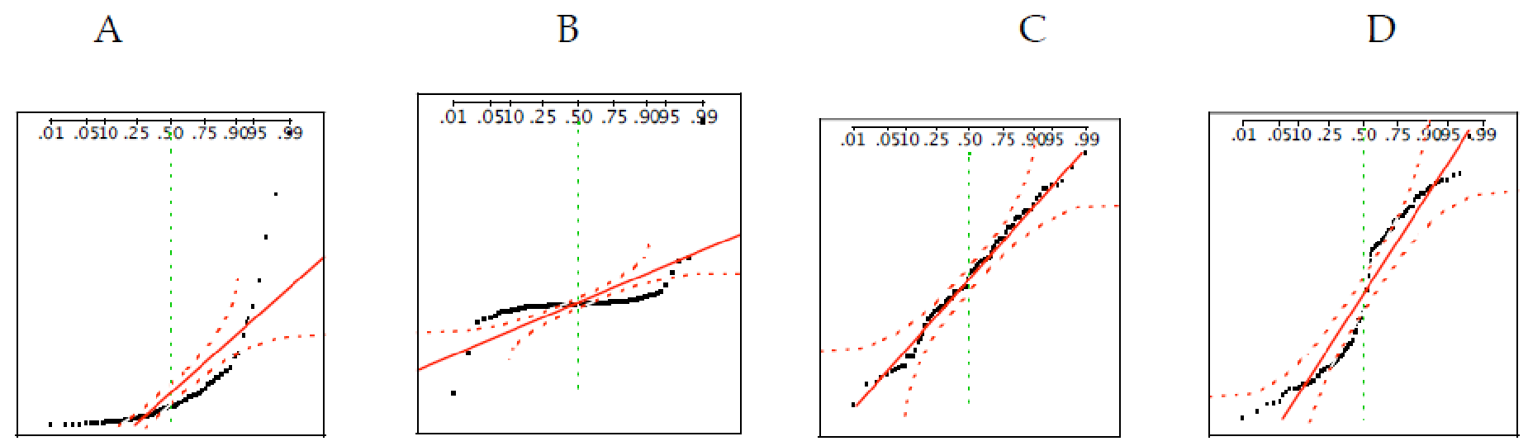

1. For each of the following statements, indicate whether it is True/False. If false, explain why.

The manager of a warehouse monitors the volume of shipments made by the delivery team. The automated tracking system tracks every package as it moves through the facility. A sample of 25 packages is selected and weighed every day. Based on current contracts with customers, the weights should have *μ* = 22 lbs. and *σ* = 5 lbs.

1. Before using a normal model for the sampling distribution of the average package weights, the manager must confirm that weights of individual packages are normally distributed.

Answer :- The statement is false because the individual value do not need to be normally distributed as long as the sample size condition is satisfied

1. The standard error of the daily average SE($\underline{x}$) = 1.

Answer :- The assertion is accurate.

The standard error of the mean is given by the formula SE(X)= σ/ $√n$ For this example, this is equal to SE(X)=5/25=1

1. Auditors at a small community bank randomly sample 100 withdrawal transactions made during the week at an ATM machine located near the bank’s main branch. Over the past 2 years, the average withdrawal amount has been $50 with a standard deviation of $40. Since audit investigations are typically expensive, the auditors decide to not initiate further investigations if the mean transaction amount of the sample is between $45 and $55. What is the probability that in any given week, there will be an investigation?
2. 1.25%
3. 2.5%
4. 10.55%
5. 21.1%
6. 50%

Answer:- D. 21.1%

1. The auditors from the above example would like to maintain the probability of investigation to 5%. Which of the following represents the minimum number transactions that they should sample if they do not want to change the thresholds of 45 and 55? Assume that the sample statistics remain unchanged.
2. 144
3. 150
4. 196
5. 250
6. Not enough information

Answer: - **D.250**

T-value for 5% is +/-1.96; it is calculated as follows:

(x̄ - μ)/(sample_standard_deviation/sqrt(n))

n = ((1.96*40)/5) **2

Round off n = 245.86240000000004 to 246.

1. An educational startup that helps MBA aspirants write their essays is targeting individuals who have taken GMAT in 2012 and have expressed interest in applying to FT top 20 b-schools. There are 40000 such individuals with an average GMAT score of 720 and a standard deviation of 120. The scores are distributed between 650 and 790 with a very long and thin tail towards the higher end resulting in substantial skewness. Which of the following is likely to be true for randomly chosen samples of aspirants?
2. The standard deviation of the scores within any sample will be 120.
3. The standard deviation of the mean of across several samples will be 120.
4. The mean score in any sample will be 720.
5. The average of the mean across several samples will be 720.
6. The standard deviation of the mean across several samples will be 0.60

**Answer: -**

   B. The standard deviation of the mean of across several samples will be 120.

As the sample size grows, the standard deviation of the sample means, sometimes referred to as the standard error of the mean, drops. Because of this, the standard deviation of the mean calculated from multiple samples will be less than that of the individual score standard deviation.

              C. The mean score in any sample will be 720.

The population mean is represented by the average GMAT score of 720. It is anticipated that the mean score in each sample will be quite close to the population mean.

D. The average of the mean across several samples will be 720.

It is anticipated that the population mean will be the same as the average of the means across several samples.

B, C, and D are the appropriate choices in this situation.